1. Manufacturing 🡪 Setting 🡪 Configuration to activate Work Orders

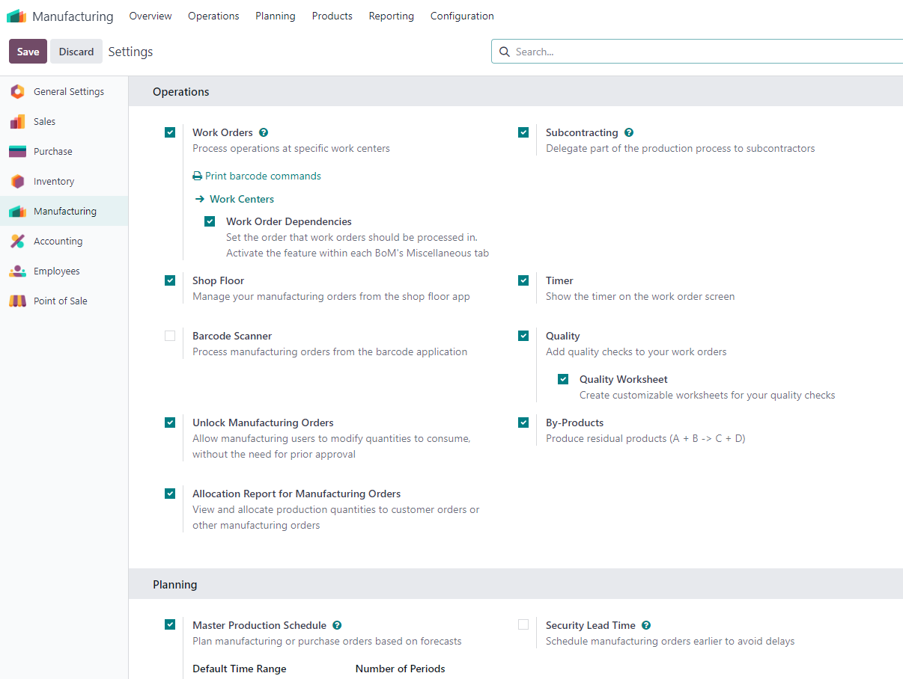

1. Manufacturing 🡪 Setting 🡪 Configuration Operations

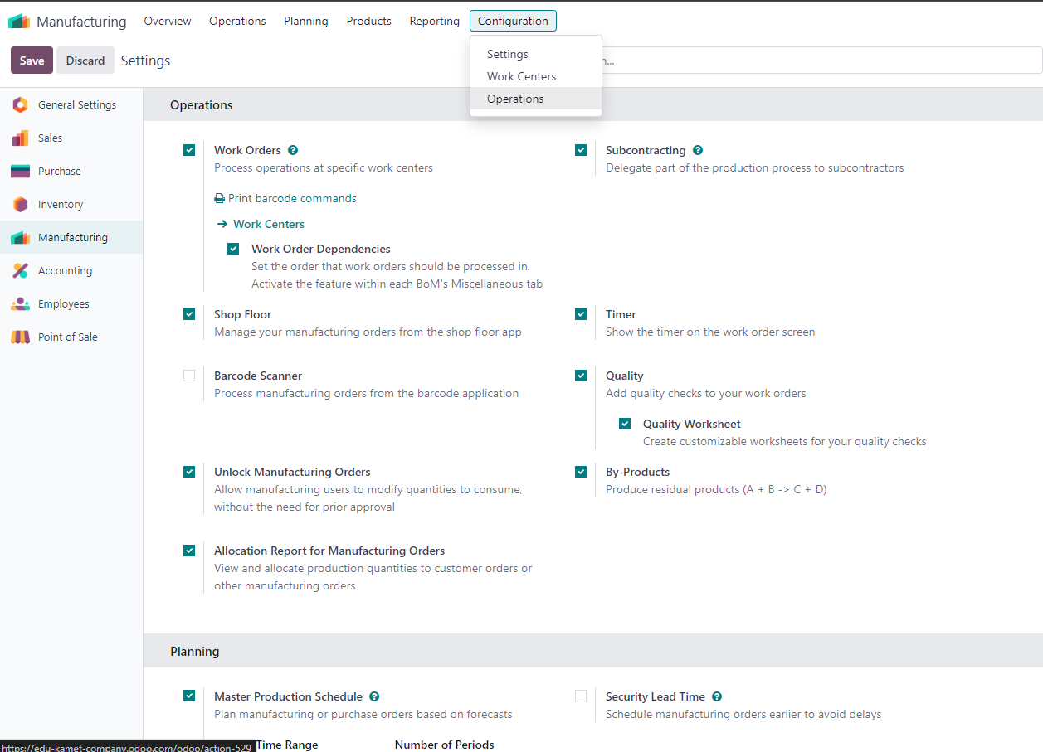

1. Manufacturing 🡪 Product 🡪 BOM

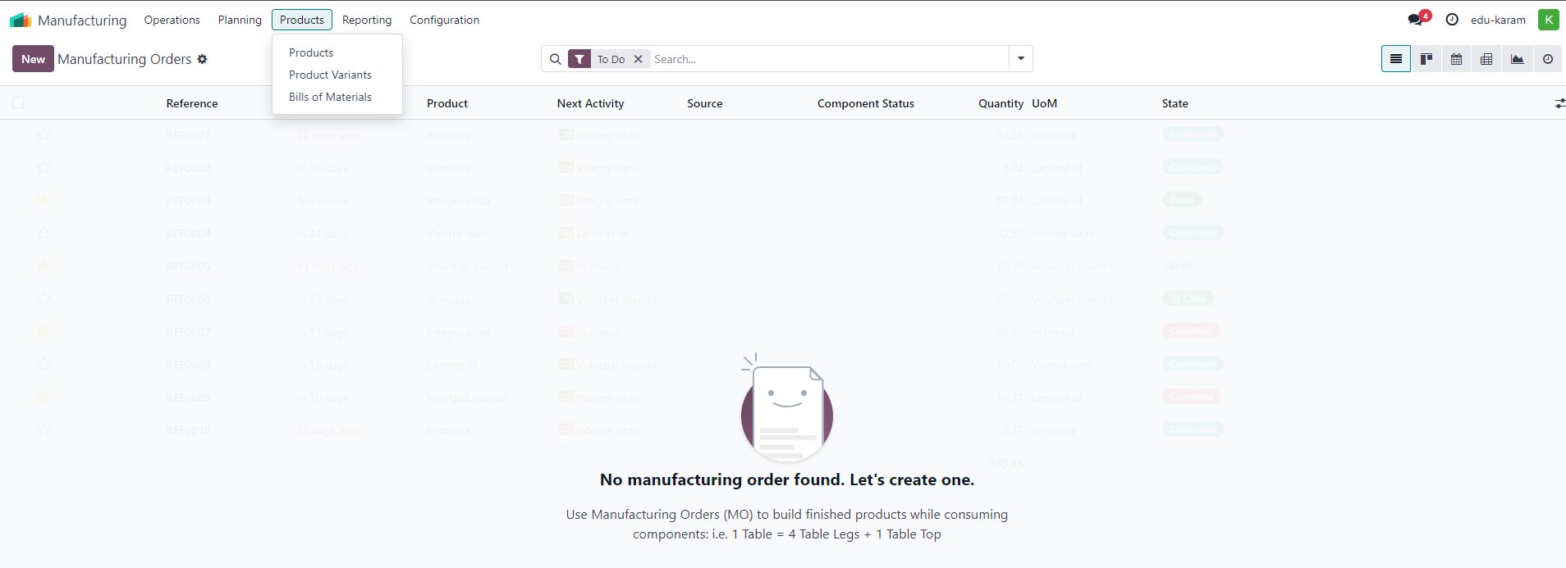

4- BOM Components of Product Women Graphic Tee

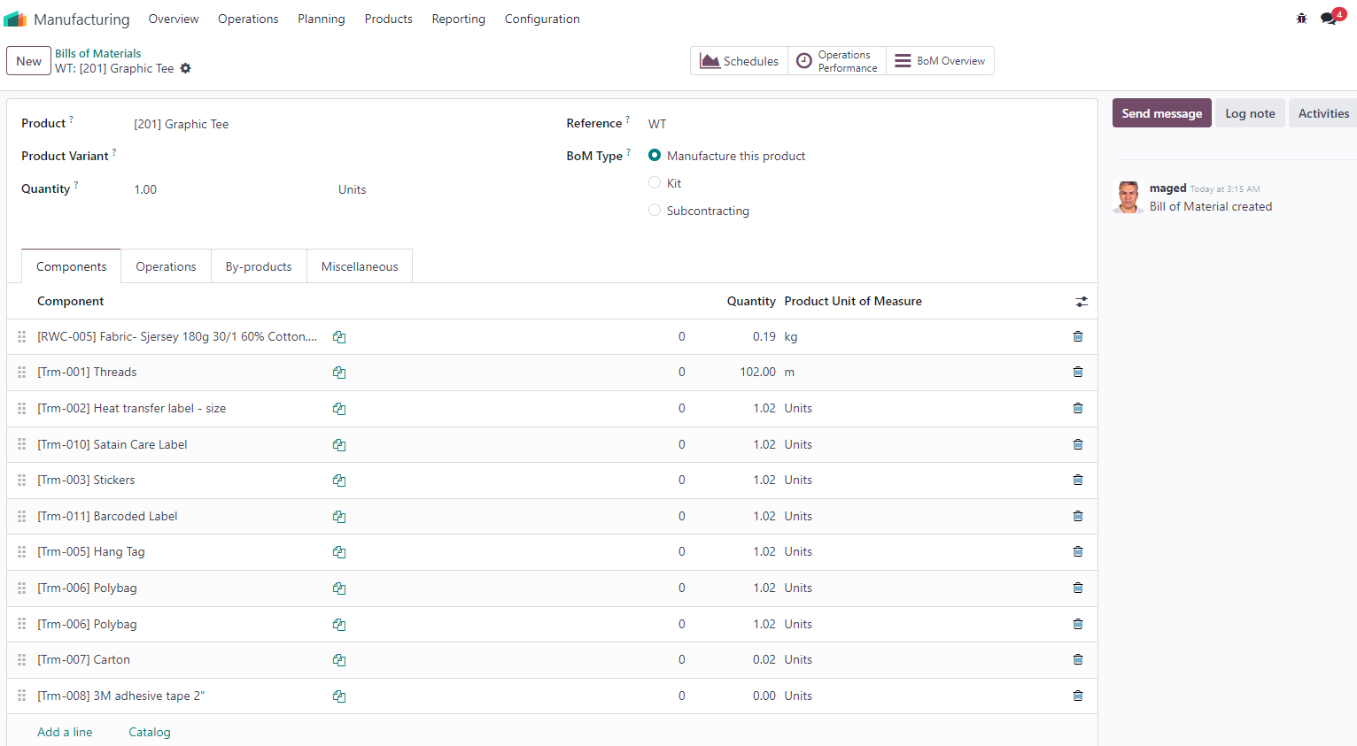

5- BOM 🡪 Link Components to specific Operations

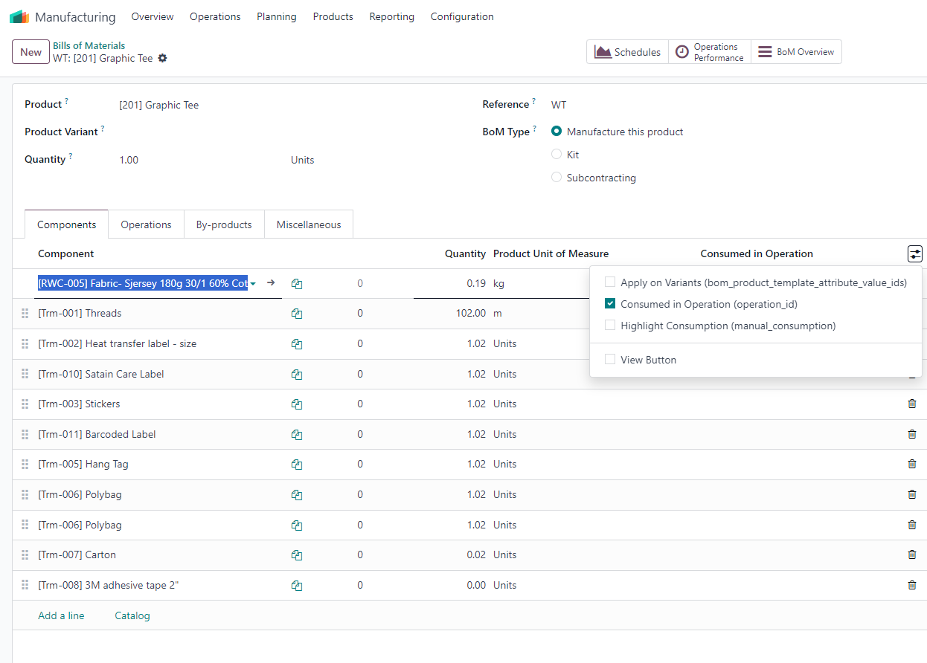

6- Manufacturing Order – Components for Product Women Tee 201 Color Black 1000 pcs

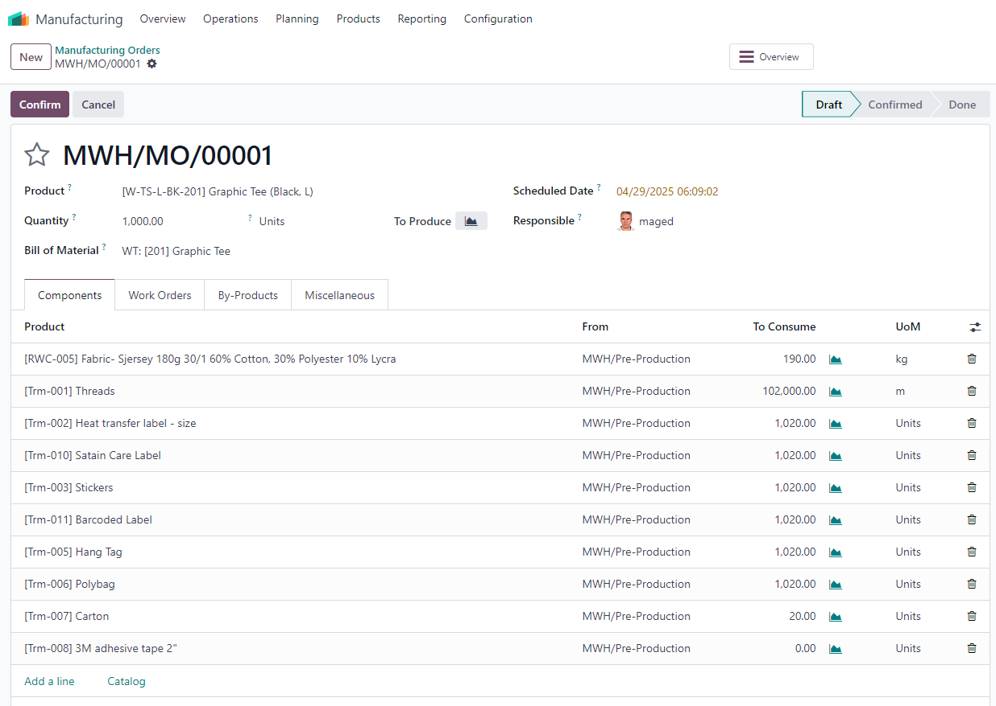

7- Manufacturing Order – Operations and Work Center for Product Women Tee 201 Color Black 1000 pcs

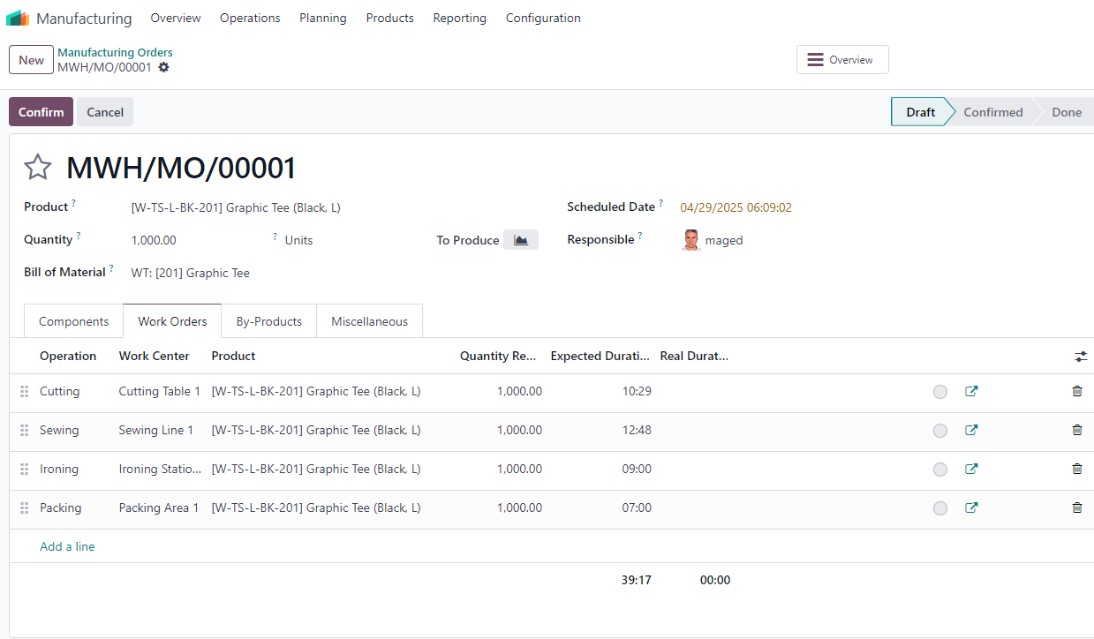

8- MO Components Location and Finshed Product Location at wearhouse

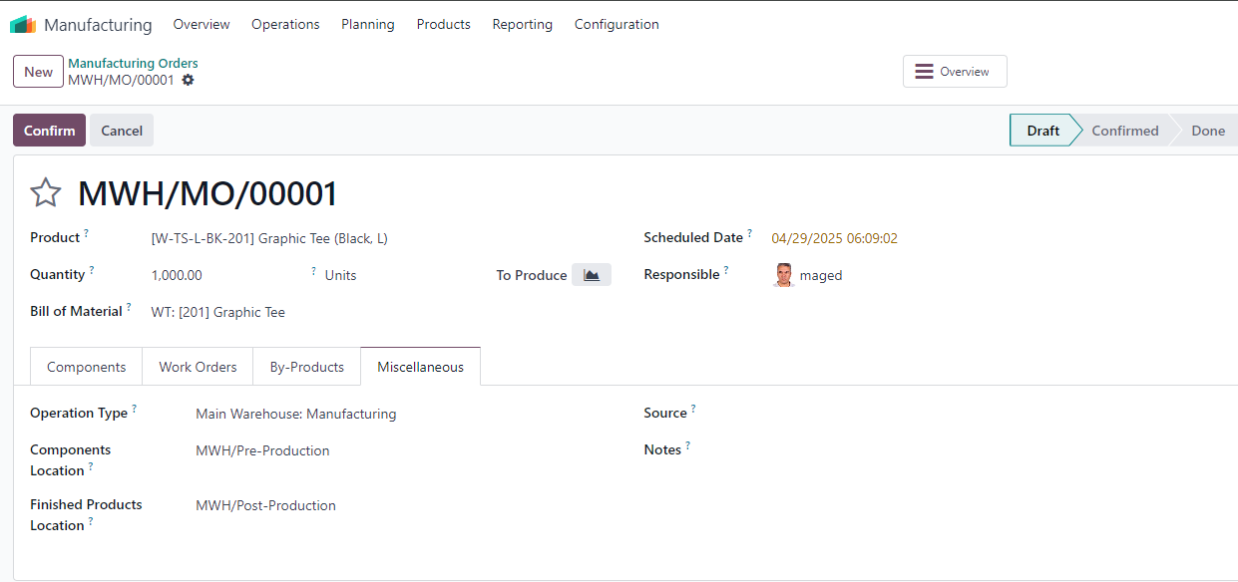

9- Confirmed MO to produce 1000 pcs

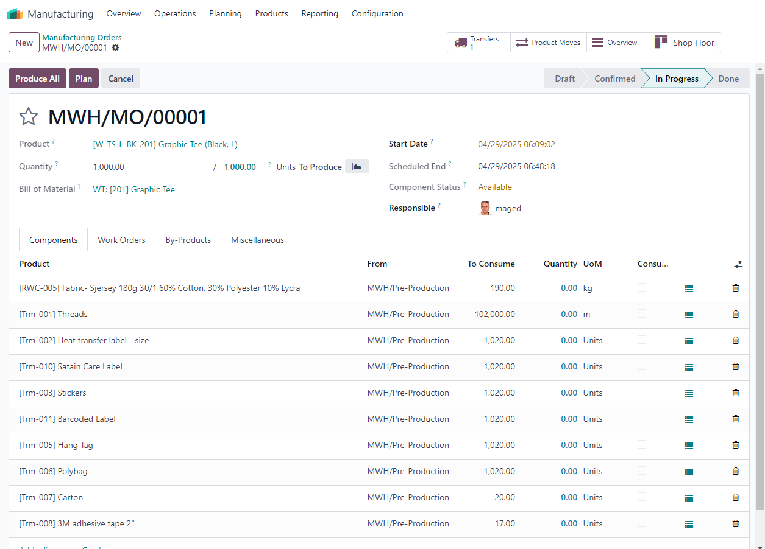

10- MO Done

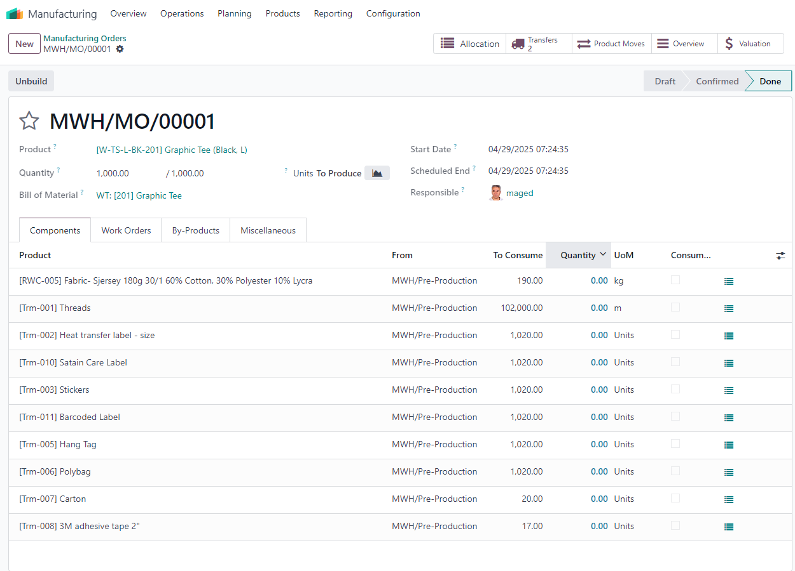

11- Transfer MO Components from Raw Matrials Loction at Main warehouse to Work Centrs

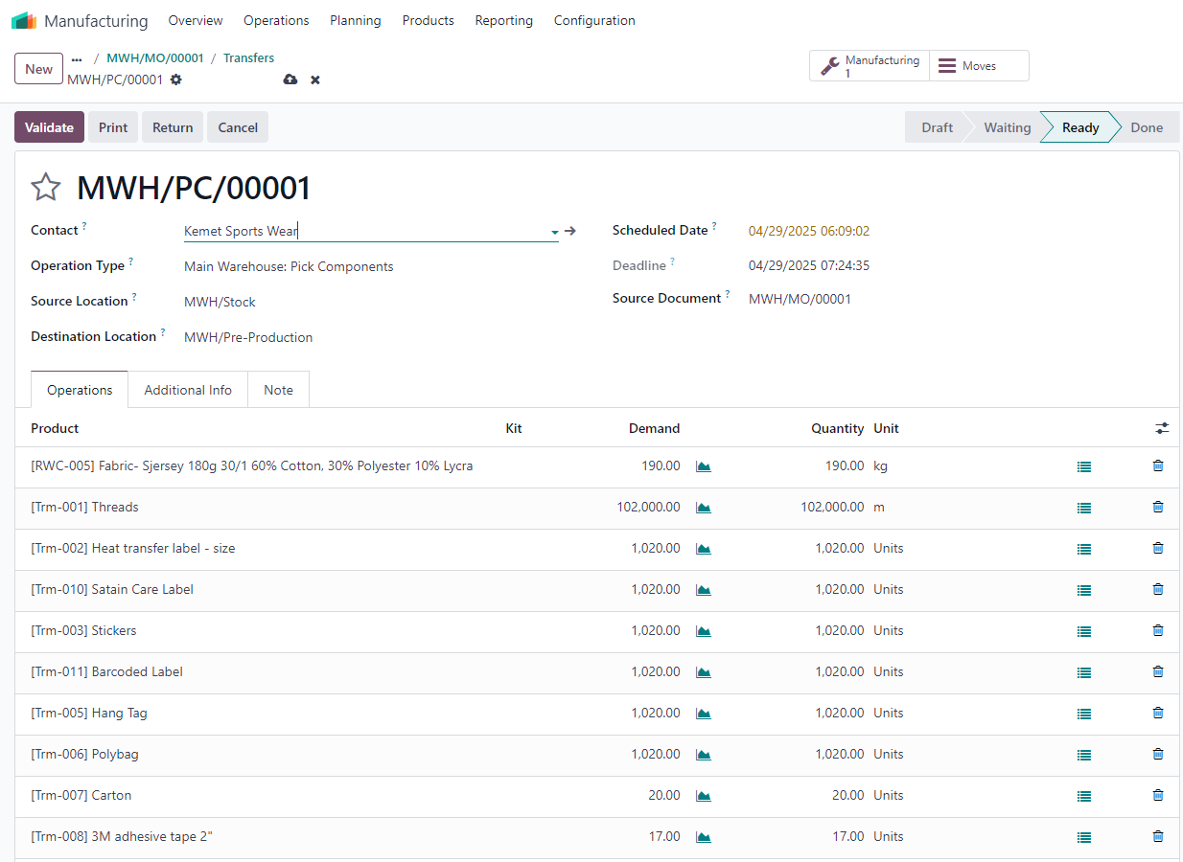

12- Transfer finished order out of Production work centers to Main Wearhouse Finished Goods location

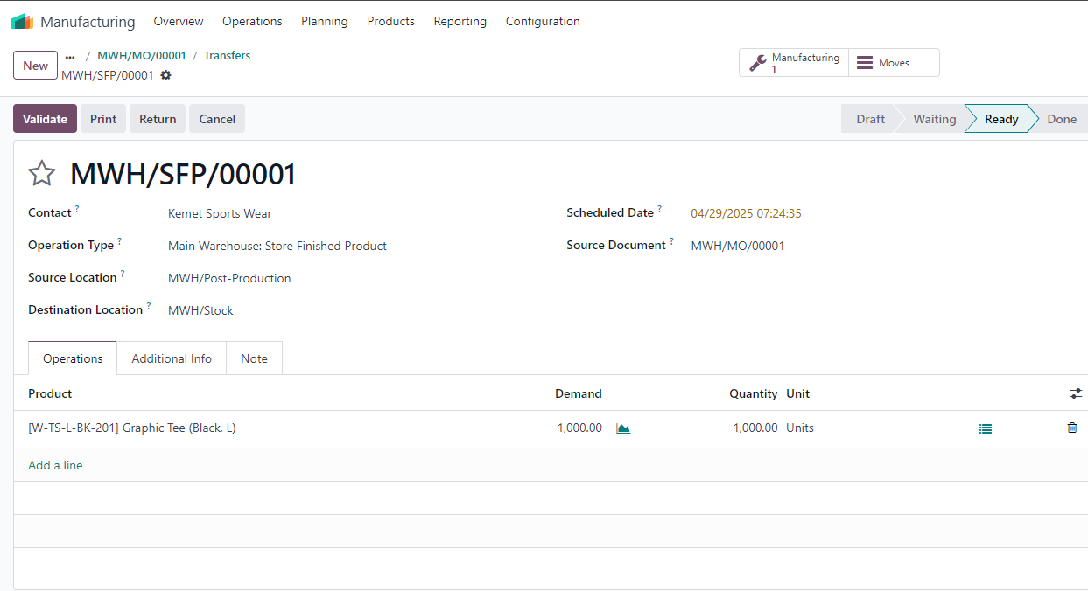

13- Move to Inventory module check out the Women Tee 201, the 1000 pcs out of production line have been automatic added to the stock on hand

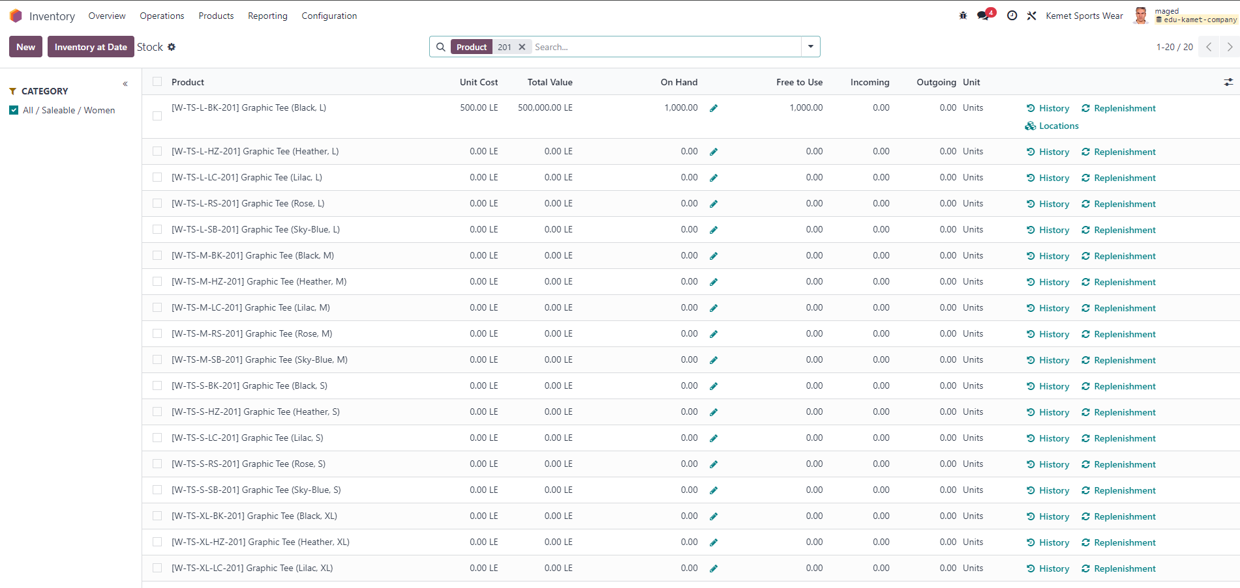

14- Move to Accounting to check the Journal

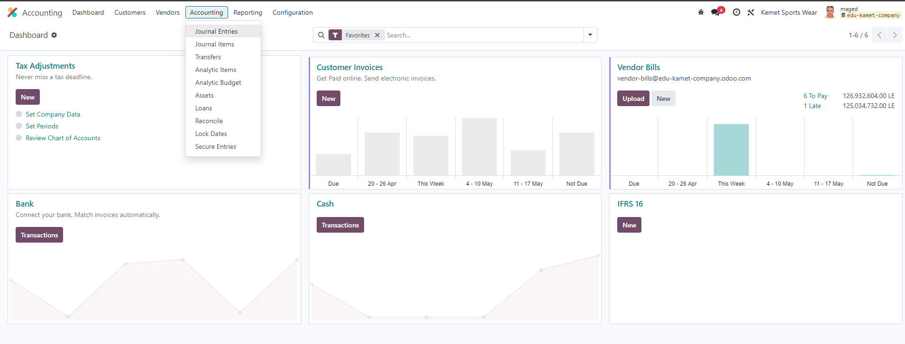

15- Automatic Journal has been created as a result of adding inventory of Women Tee 201 the value of 1000 pcs from outline of production to Stock Inventory

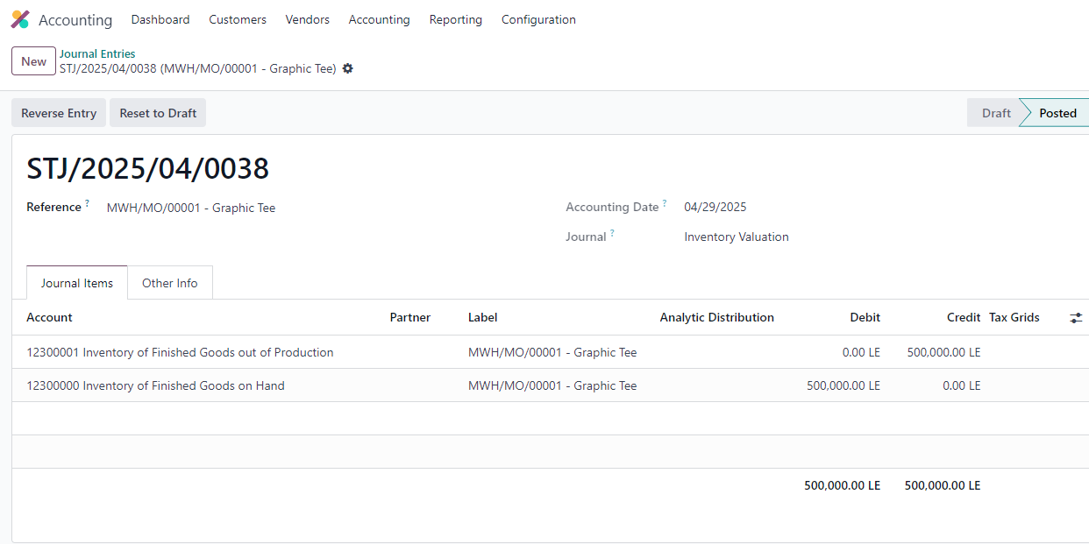

16 – Create Product Men’s Polo Shirt with Attributes Color & Size

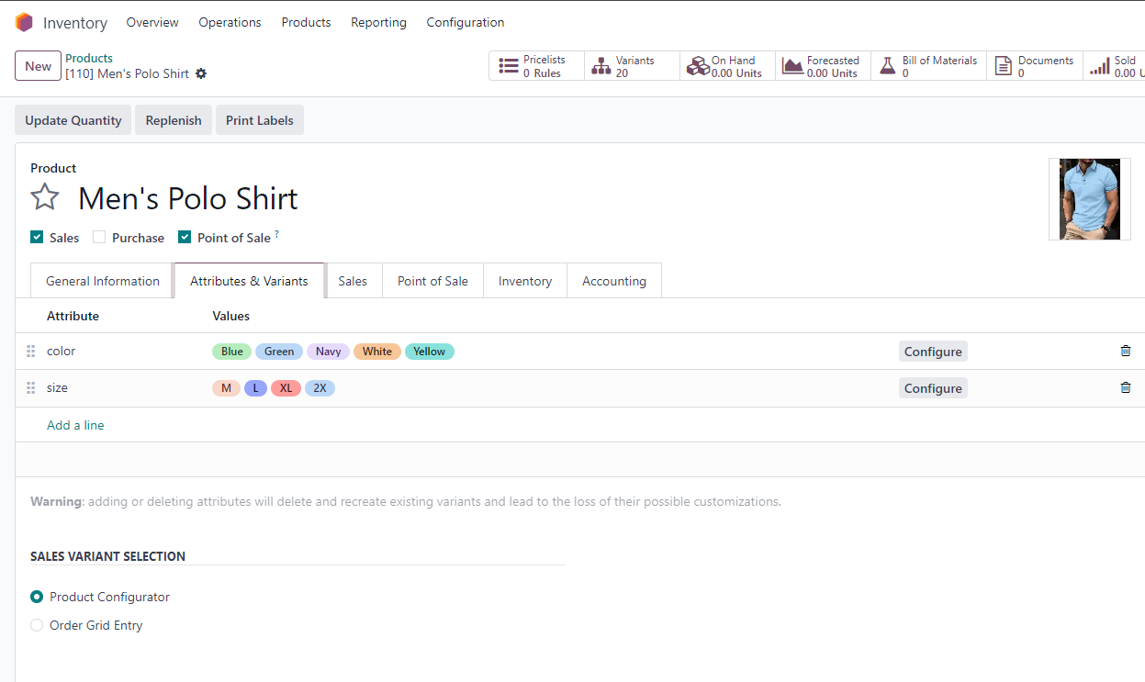

17- Purchase Agreement to supply Pique fabric from 3 Local Vendors

18- Compare 3 RFQ for 3 different Local Vendors

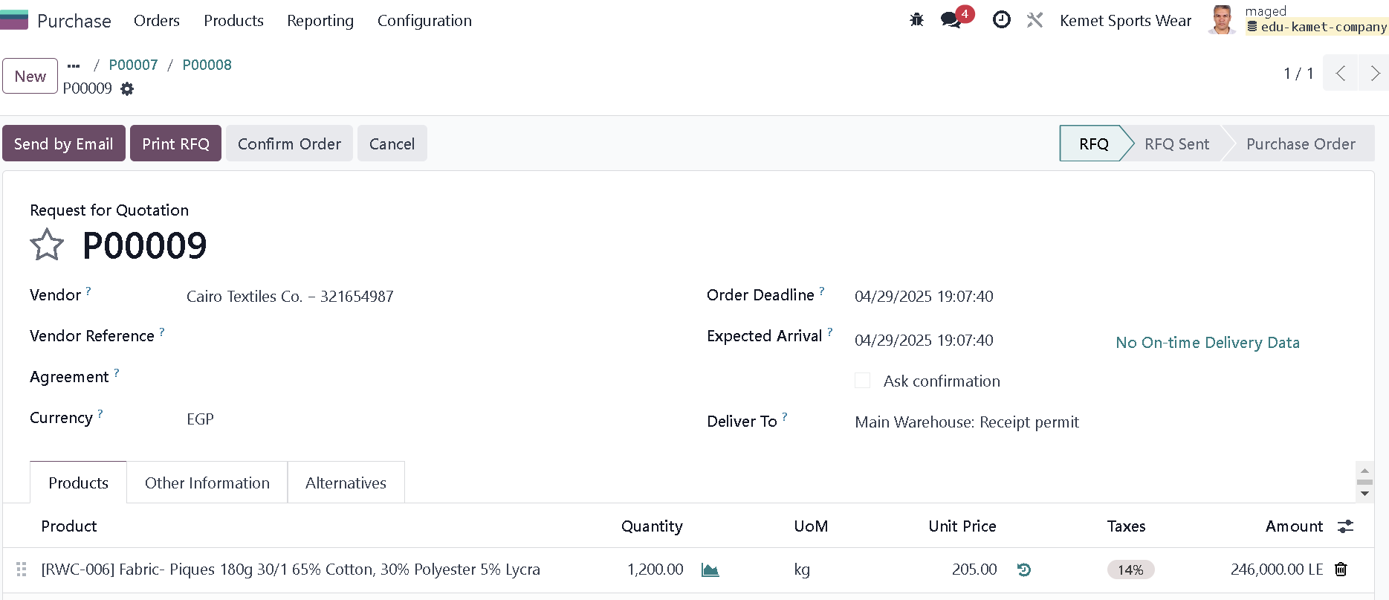

19 – Compare Alternatives RFQs

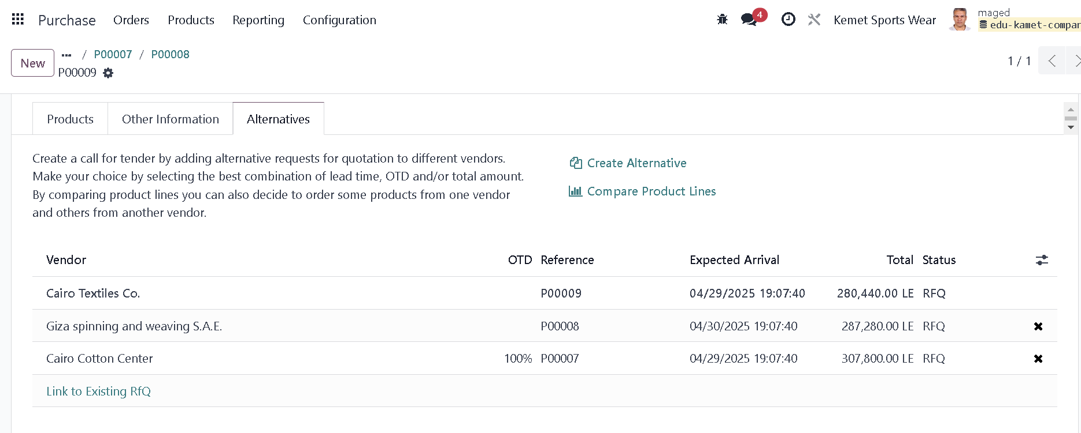

20 – Compre 3 RFQ and choose the best offer

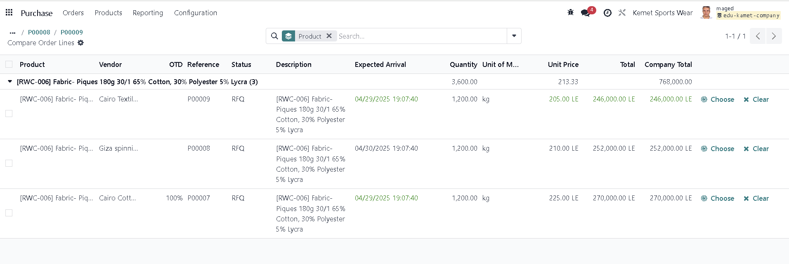

21- Choose the best which indicate by Odoo in Green highlight

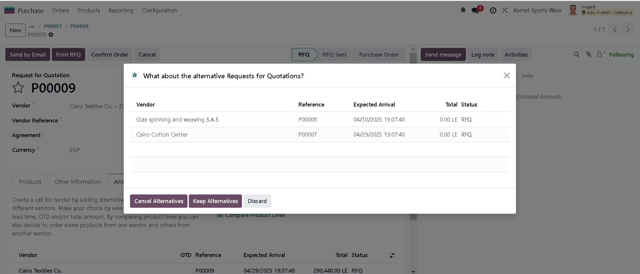

22 – Vladit to receive purchased fabric in warehouse to starte production

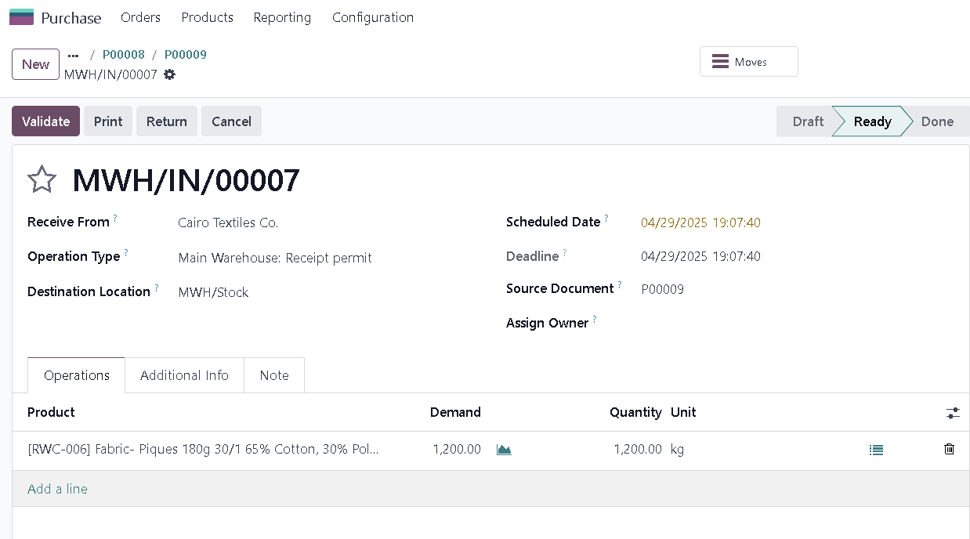

23 – add new vendor for button product

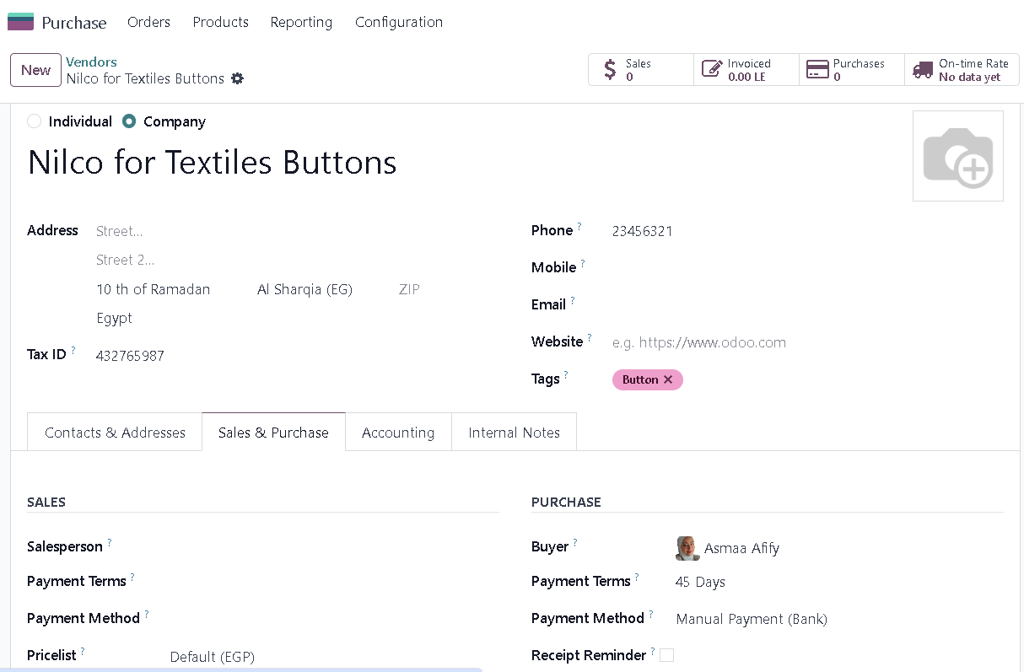

24- BOM for Product Men’s Polo Shirt

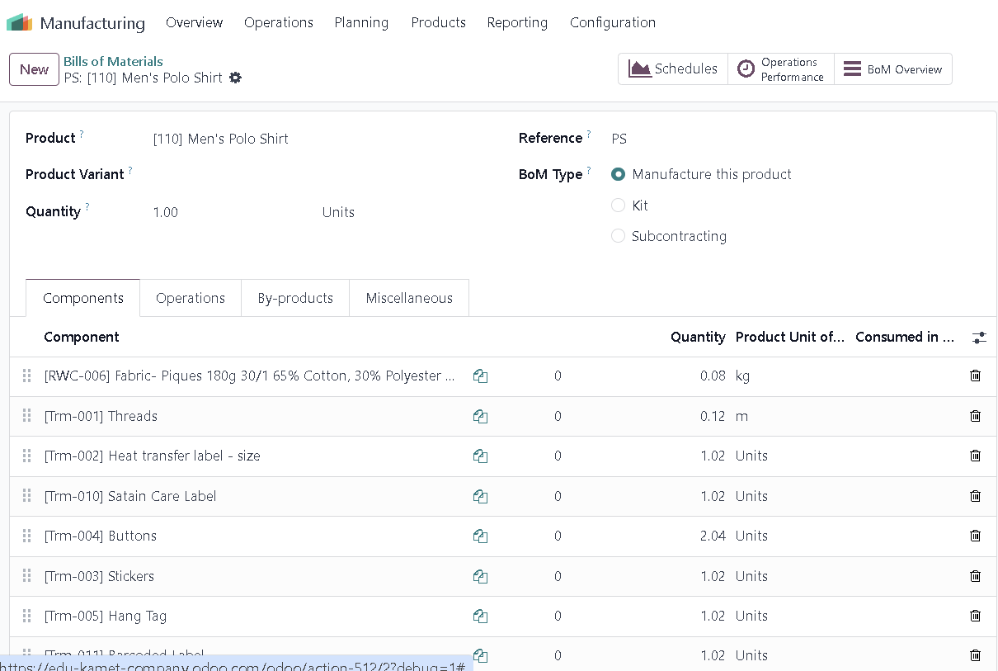

25- BOM operations

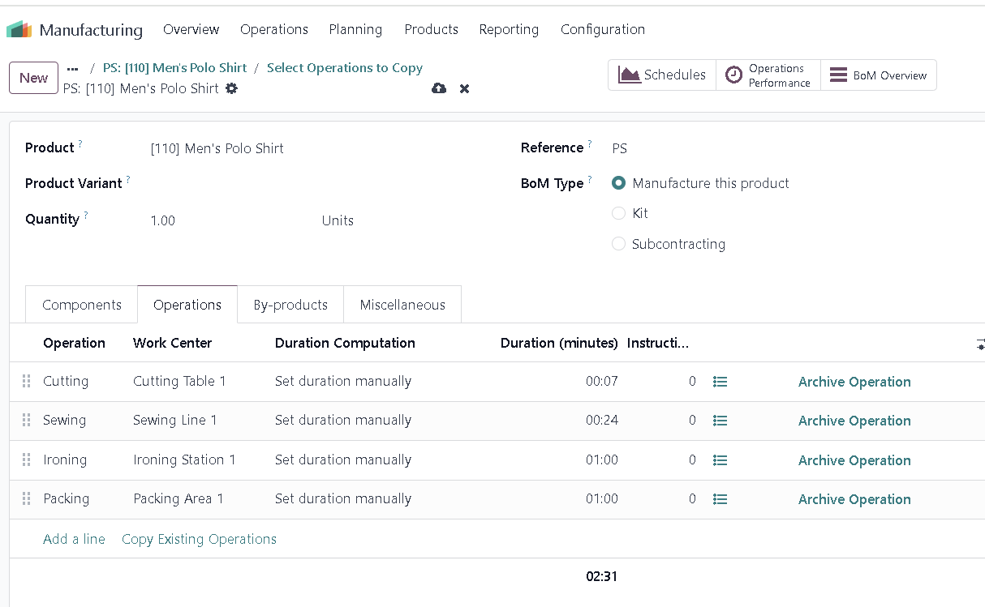

26- BOM – Operations Dependencies

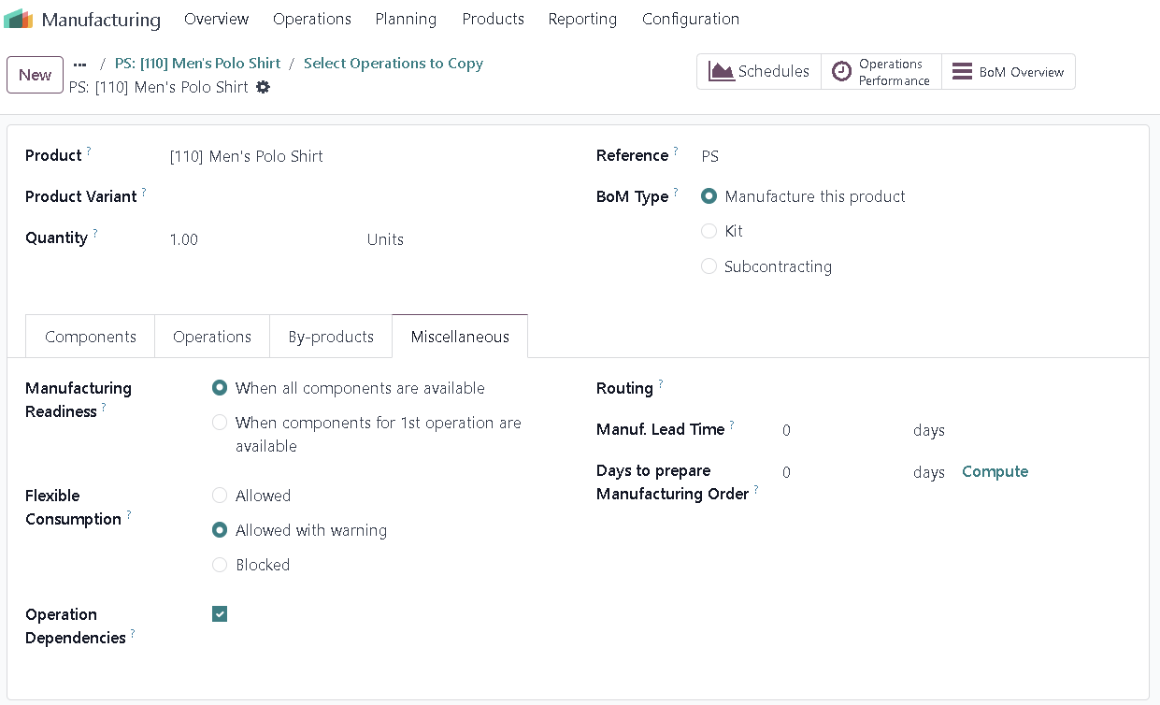

27 – Add packing operation instruction in BOM

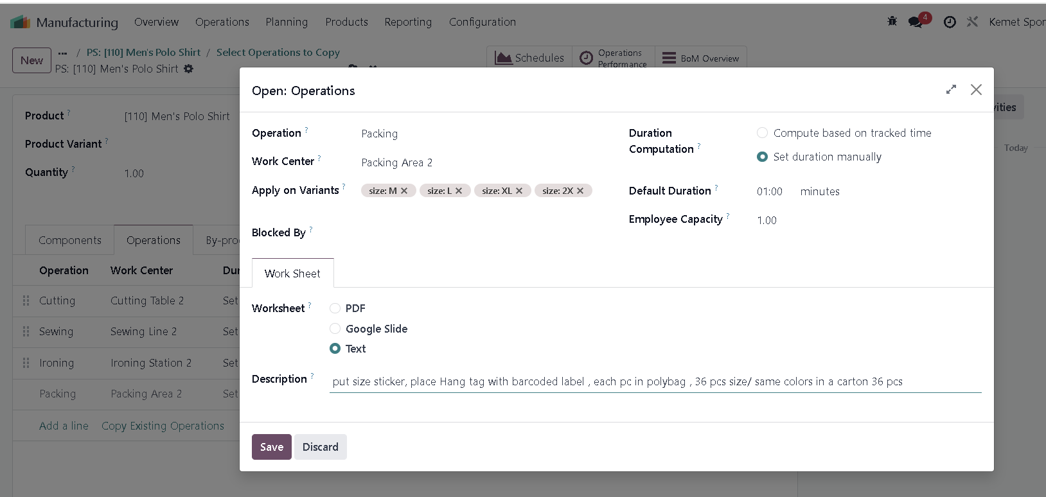

28 – BOM is ready to use in Manufacturing Order for producing 1260 pcs of Men’s Polo Shirt color White in Size M, L, XL and 2XL

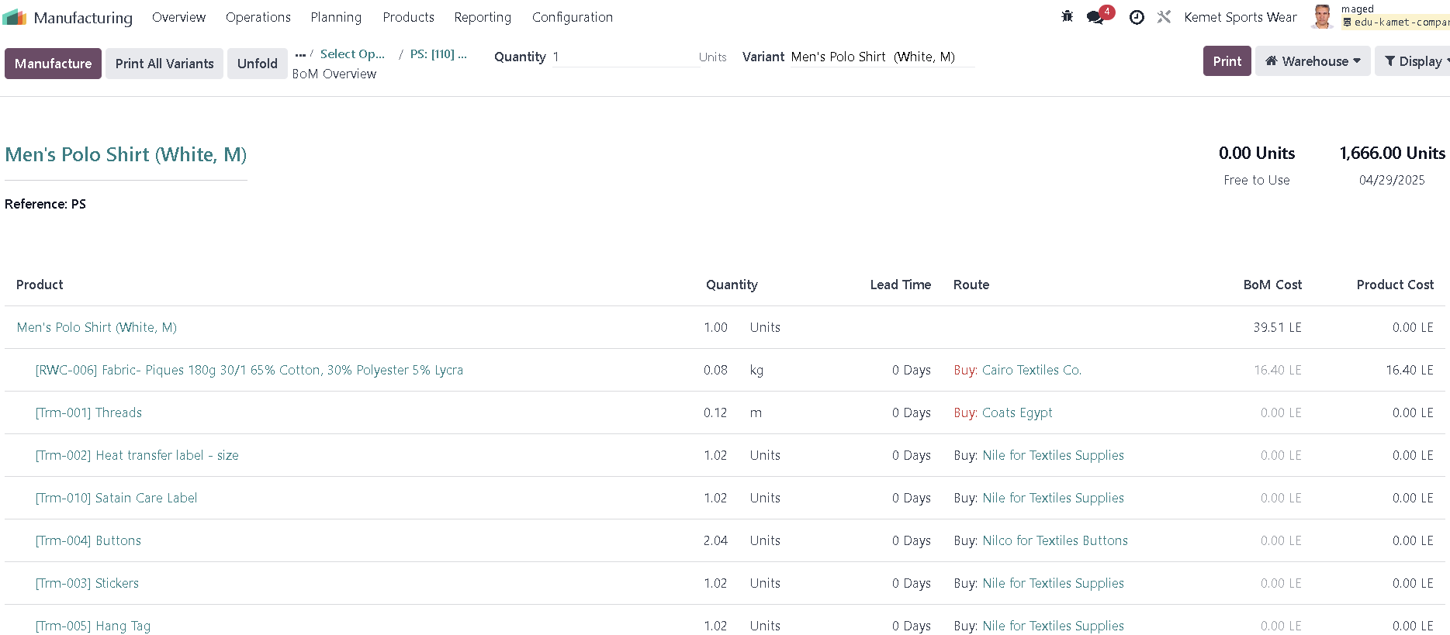

29- Create Manufacturing Order

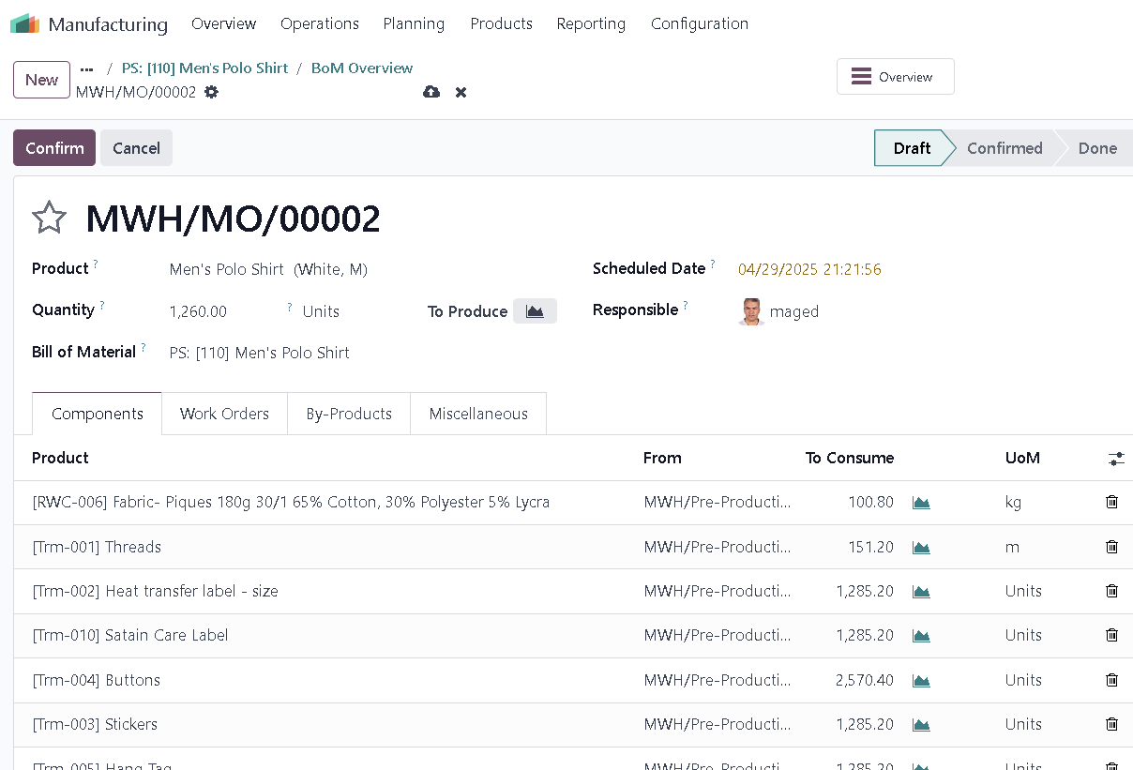

30 – Confirmed MO to Produce 1260 Pcs

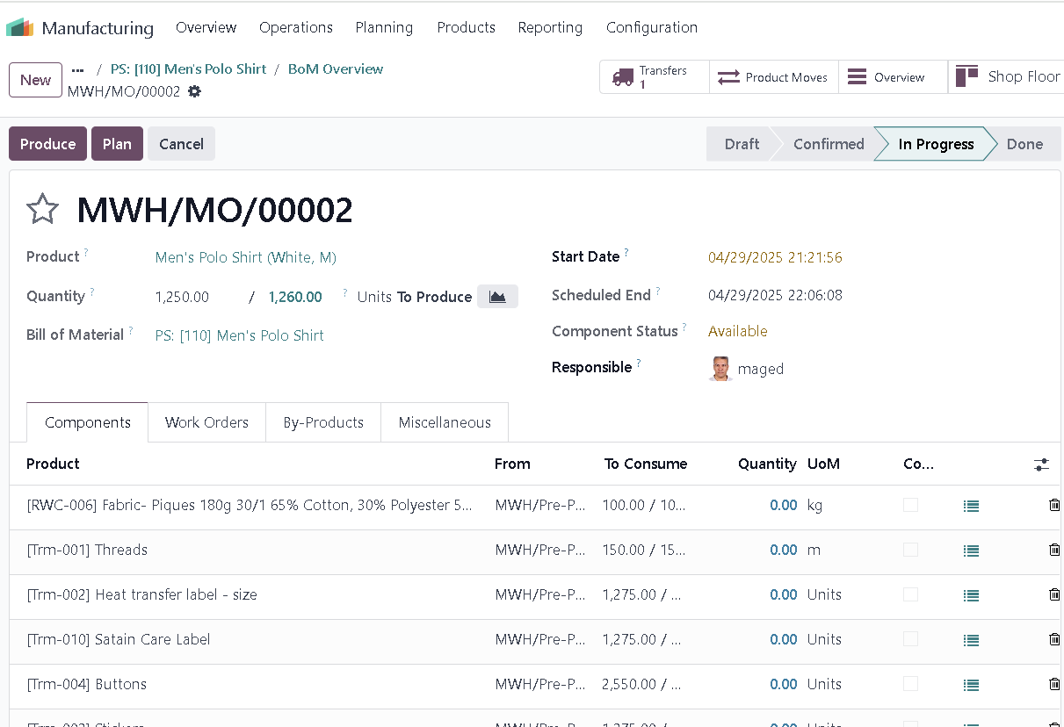

31 – Some Components QTY is below required QTY to complete the production order , So Oddo Make Sub Order and give warning to complete backorder

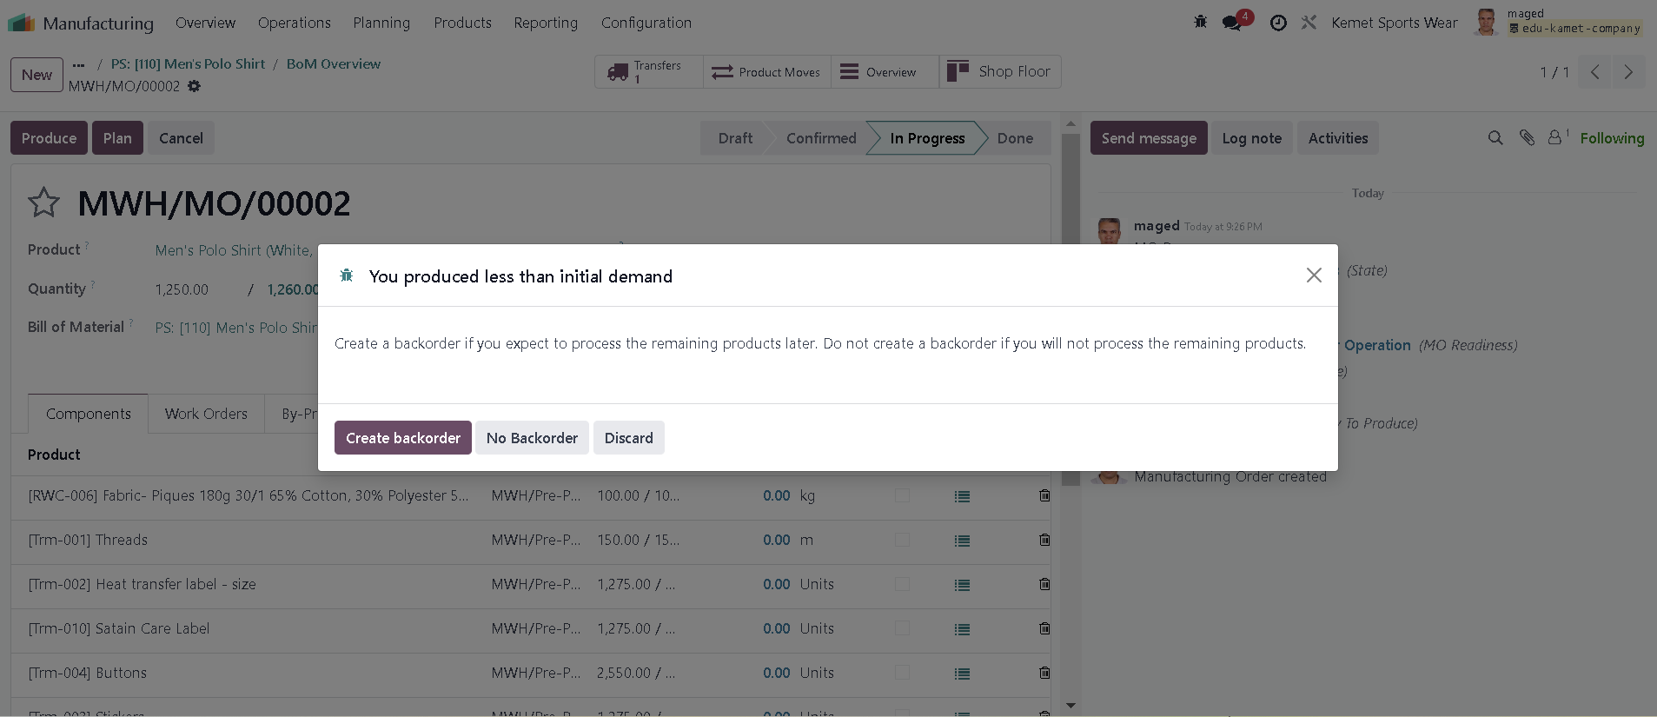

32 – MO divided into 2 order based on aviliable compmenets qty

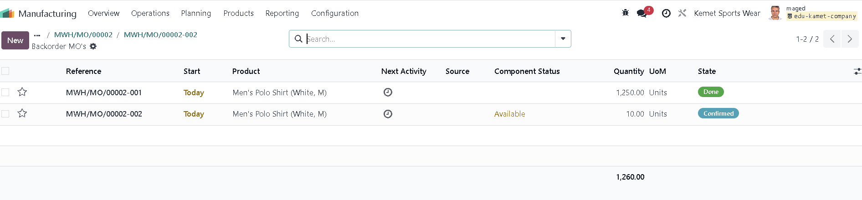

33- transfer post production into main warehouse

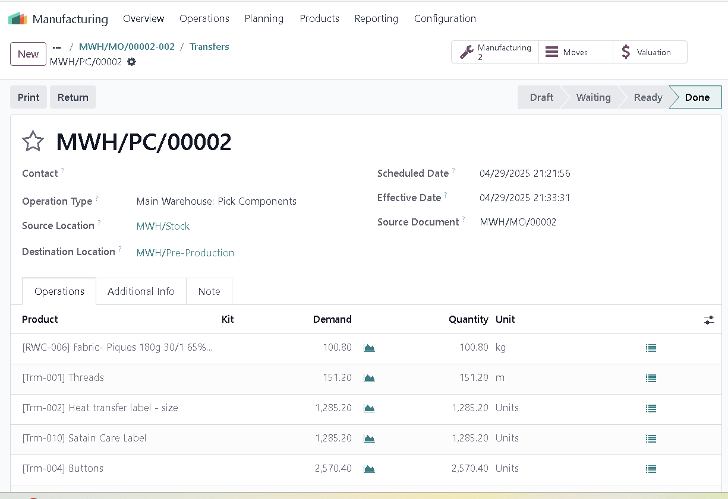

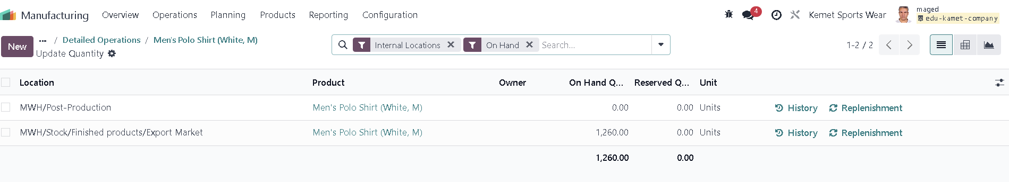

**Pro Sync integrated Solutions** **Kemet Sportswear Co.**

**Project Manager** **Project Manager**

Mr. Maged Kamel MR. Atef Ibrahim